Motional AD LLC.

Component Common Requirement Document

ENG-REQ-EMC-1.3

**Electromagnetic compatibility Requirements for Components**

**Revision Record**

|  |  |  |  |
| --- | --- | --- | --- |
| Revision Level | Revision Date | Author | Change Description and Section(s) Affected by The Change |
| 1.0 | Nov 11, 2020 | Wun Leng, Lee | Initial draft |
| 1.1 | Dec 19, 2020 | Wun Leng, Lee | Draft for review |
| 1.2 |  |  | Draft for review |
|  |  |  |  |
|  |  |  |  |
|  |  |  |  |
|  |  |  |  |
|  |  |  |  |
|  |  |  |  |

**Table of Contents**

1. Scope of the Document 5

1.1 Scope of Document 5

1.2 Word Format and Conventions 5

2. Overview 6

2.1 Purpose 6

2.2 Communications 6

3. EMC Requirements 6

4. Use Cases and Component Types 7

5. Standardization and Its Limitations 7

6. Reference Documents 8

7. Abbreviations 8

8. Operating modes based 9

8.1 Operating mode 1 9

8.2 Operating mode 2 9

8.3 Operating mode 3 9

9. Functional Performance Status Classification (FPSC) 9

9.1 Functional Performance Status 9

9.1.1 Status I 9

9.1.2 Status II 9

9.1.3 Status III 10

9.1.4 Status IV 10

9.2 Test Severity Level 10

9.3 FPSC approach 10

10. List of components considered 11

11. Component Category Classification table 11

12. Test and Standard Selection Matrix 11

13. General Lab Test Requirements, If not provided 13

14. Requirements 13

14.1 Radiated Emission in ALSE 13

14.2 Conducted Emissions - Voltage on Power leads 13

14.3 Conducted Emissions - Current probe on cable harness 13

14.4 Interference immunity - BCI on cables 14

14.5 Interference Immunity - ALSE (Antenna) 14

14.6 Interference Immunity – Magnetic Fields 14

14.7 Conducted Transient on power lines 14

14.8 Conducted Immunity to Transient on power lines 14

14.9 Coupled Transient Interference on cable harness 14

14.10 Powered Electrostatic Discharge (ESD) 14

14.11 Handling Electrostatic Discharge (ESD) 15

15. References 16

15.1 Industry Standards 16

15.2 Motional Requirements 16

15.3 Acronyms and Terms 17

# Scope of the Document

## Scope of Document

This document is a Process and Methodology for Electromagnetic compatibility.

## Word Format and Conventions

The word SHALL denotes a mandatory design requirement. The word SHOULD denotes a desired, but not mandatory design requirement. The word WILL denotes a statement of fact.

# Overview

Motional is preparing to launch its first Automated Mobility on Demand (AMoD) product at scale for use in ride-hailing networks in the United States, the European Union, Singapore, China, and Japan. That product launch includes four key elements to the product:

1. automated driving tech (components, computers, software),
2. vehicle platform,
3. mobility services cloud, and
4. reference infrastructure solution.

Motional’s product sale encompasses all four of these elements in a turnkey sale directly to ride-hailers.

## Purpose

As part of the requirements stipulated for each component within the architecture for the product, common requirements have been identified for Electromagnetic compatibility and hereby documented with the intent that ALL component suppliers to the vehicle architecture demonstrate compliance.

## Communications

Please confirm receipt of this document to [wun.leng.lee@motional.com](mailto:wun.leng.lee@motional.com) Additionally, if further clarification or questions arise, please direct your questions to her.

## EMC Requirements

- In vehicles, electrical/electronic components and subsystems used by Motional Company should clear an EMC evaluation.

- In terms of DUT and vehicle EMC standards, tests can be conducted under special circumstances, and required performance can be adjusted prior to revision of the standard to reflect market trends such as the application of new technologies, field claims, and so on. The DUT supplier is responsible for inspecting the improvement, submitting reviews on additional part tests, and conducting enhanced and additional tests.

## Use Cases and Component Types

The following type of [Component] are considered:

1. A component or module that contains active electronic devices. (EC)
2. An electronic component or module that contains magnetically sensitive elements. (EM)
3. An electronic component or module operated from a regulated power source in another module. This is usually a sensor providing input to a controller. (ES)

## Standardization and Its Limitations

- The standard's test methods and technical specification were based on an international standard for EMC testing of components and vehicles that was distributed or under review for revision, and a part of the experience gained was reflected to ensure EMC performance in actual vehicles.

- The test methods and performance criteria are protected depending on the Motional components and specifications, and the restrictions are mostly focused on Europe and the United States based on Motional requirements. Aside from US and European assessments, normal limits will be considered during tests depending on the country's requirements.

- Product suppliers and Motional Company's responsible engineering-design/distribution departments should decide the following products.

* Data for determining the DUT's feature classification (CLASS 1/2/3/4)
* Choosing EMC test products that apply to the DUT
* Determination of DUT test mode and definition (tolerance) of DUT regular activity status.
* Norm Of ENGINEERING
* Writing an EMC Research Plan
* Deciding on a facility for DUT testing
* Submitting a test report to Motional Company's EMC Test Department

- If the contents of a different component standard conflict with the standard, the standard prevails.

- All electrical/electronic components and sub-systems should comply with the standard requirement.

- The engineering-design/distribution divisions of the Motional company, as well as product suppliers, are in charge of identifying the service output status and deciding the test mode of the DUT.

- Motional engineering-design/distribution divisions are in charge of determining if the standard's specifications are relevant.

- It is the responsibility of component manufacturers to perform tests in accordance with the specifications of the specification.

- The final degree of satisfaction with the DUT's EMC test result should be decided by Motional Company's EMC test department.

- The specification was written to anticipate problems, such as consumer satisfaction with performance/quality, and it will be updated to meet the vehicle's target level.

- There may be a discrepancy in test results due to the lack of an appropriate correlation coefficient for the correlation between part and in-vehicle tests, as well as measurement uncertainty.

As a result, EMC tests must be carried out in real vehicles that are fitted with the entire system..

- The typical vehicle test result must not be used as a substitute for the DUT test result.

- If the standard needs to be changed, a request should be made to Motional Company's EMC test department, and the requested item will be checked and either reflected in the next revision or immediately updated, depending on its value.

- Any DUT tested according to the standard must follow the standard when randomly extracting approved components from the proto and pilot production process (including the pilot production preparation phase). The related component manufacturers must be pre-qualified with appropriate samples for this purpose by developing their own reliable verification system.

# Reference Documents

|  |  |
| --- | --- |
| **Standard** | **Description** |
| CISPR 25:2016 | Vehicles, boats and internal combustion engines - Radio disturbance characteristics - Limits and methods of measurement for the protection of on-board receivers |
| ISO 11452-4: 2020 | Road vehicles — Component test methods for electrical disturbances from narrowband radiated electromagnetic energy — Part 4: Harness excitation methods |
| ISO 11452 - 2:2019 | Road vehicles — Component test methods for electrical disturbances from narrowband radiated electromagnetic energy — Part 2: Absorber-lined shielded enclosure |
| ISO 11452 - 8:2015 | Road vehicles — Component test methods for electrical disturbances from narrowband radiated electromagnetic energy — Part 8: Immunity to magnetic fields |
| ISO 11452-9:2012 | Road vehicles — Component test methods for electrical disturbances from narrowband radiated electromagnetic energy — Part 9: Portable transmitters |
| ISO 7637-2:2011 | Road vehicles — Electrical disturbances from conduction and coupling — Part 2: Electrical transient conduction along supply lines only |
| ISO 7637-3:2016 | Road vehicles — Electrical disturbances from conduction and coupling — Part 3: Electrical transient transmission by capacitive and inductive coupling via lines other than supply lines |
| EN 61000-4-2:2008, ISO 10605:2008 | Electromagnetic compatibility (EMC) - Part 4-2: Testing and measurement techniques - Electrostatic discharge immunity test, Road vehicles — Test methods for electrical disturbances from electrostatic discharge |
| ISO 7637-1: 2015 | Road vehicles — Electrical disturbances from conduction and coupling — Part 1: Definitions and general considerations |
| ISO 11452-1: 2015 | Road vehicles — Component test methods for electrical disturbances from narrowband radiated electromagnetic energy — Part 1: General principles and terminology |
| IEC 61000-3-2:2018 | Electromagnetic compatibility (EMC) – Part 3-2: Limits – Limits for harmonic current emissions (equipment input current ≤ 16 A per phase) |
| IEC 61000-3-3:2013/AMD2:2021 | Electromagnetic compatibility (EMC) – Part 3-3: Limits – Limitation of voltage changes, voltage fluctuations and flicker in public low-voltage supply systems, for equipment with rated current ≤ 16 A per phase and not subject to conditional connection |
| IEC 61000-3-4:1998 | Electromagnetic compatibility (EMC) - Part 3-4: Limits - Limitation of emission of harmonic currents in low-voltage power supply systems for equipment with rated current greater than 16 A |
| IEC 61000-3-5:2009 | Electromagnetic compatibility (EMC) – Part 3-5: Limits – Limitation of voltage fluctuations and flicker in low-voltage power supply systems for equipment with rated current greater than 75 A |
| IEC 61000-3-11:2017 | Electromagnetic compatibility (EMC) - Part 3-11: Limits - Limitation of voltage changes, voltage fluctuations and flicker in public low-voltage supply systems - Equipment with rated current ≤ 75 A and subject to conditional connection |
| IEC 61000-3-12:2011 | Electromagnetic compatibility (EMC) - Part 3-12: Limits - Limits for harmonic currents produced by equipment connected to public low-voltage systems with input current >16 A and ≤ 75 A per phase |

# Abbreviations

* Absorber-Lined Shielded Enclosure: ALSE
* Bulk Current Injection: BCI
* Current Injection Probe: CIP
* Current Measuring(Monitoring) Probe: CMP
* Device Under Test: DUT
* Electromagnetic Compatibility: EMC
* Electrostatic Discharge**:** ESD

# Operating modes based

Need to be defined on component level for EMC requirements

# Functional Performance Status Classification (FPSC)



Need to be defined on component level for EMC requirements

# List of components considered

LR-LIDAR, SR-LIDAR, RADAR, CAMERAS (1003-Narrow, 1004-Moderate, 1005-Wide), GNSS (IMU / GPS / V2X), External Microphone, Services/Teleops (RVA), Drive By Wire Controller, Mission Services Platform, AV Compute, Cabin Monitoring System, AEB Hardware Solution (Radar, Camera),R&D Logging, R&D Compute, Exterior Audio (Speaker), Passenger Displays (AVN), External Display(FRT), Authentication Pad, Passenger Displays (RSE), Side LED strips

# Component Category Classification table

|  |  |
| --- | --- |
| **Component Category Classification Table** | |
| **Category** | **Component Category Description** |
| **L1** | Any module which does not consist electronic components (ex: Speaker, lamp, etc.) |
| **L2** | Module having passive components with no control function; such as inductor, capacitor, filter and LED's |
| **L3** | Modules having Control and monitoring feature; such as units consisting of active senor, display system, microcontrollers, electronic modules, transistors and integrated circuits |
| **SUB Category for additional tests** | |
| **SC1** | Motors and electronically controlled motors are examples of electronic components that include an electronically controlled motor or a magnetically driven component within their package or drive an external inductive system. |
| **SC2** | Electronic parts like key fob and tire pressure monitor, which does not have a wired connection to vehicle |
| **SC3** | Switching components such as solenoid and relays pulsed at a rate < 100Hz. |
| **SC4** | An auto cycle brush commutated DC electric motor with a long operating time, say > 5 seconds |
| **SC5** | For any electric power system, an electronic component that operates at more than 60V. |
| **SC6** | Magnetically sensitive elements which are located in an electronic unit. |
| **SC7** | Electronic component that gets its power from another component's controlled power supply. Typically, this is a sensor that provides information to a controller. |
| **SC8** | Electronic component connected to AC mains |
| **SC9** | Pulse rates of 100Hz or higher which are used in inductive units. |

# Test and Standard Selection Matrix

|  |  |  |  |  |  |  |  |  |  |  |  |  |  |  |  |  |  |  |  |  |  |  |  |  |  |  |  |  |  |  |  |
| --- | --- | --- | --- | --- | --- | --- | --- | --- | --- | --- | --- | --- | --- | --- | --- | --- | --- | --- | --- | --- | --- | --- | --- | --- | --- | --- | --- | --- | --- | --- | --- |
| **Test and Standard standard Matrix** | | | | | | | | | | | | | | | | | | | | | | | | | | | | | | | |
| **Tests** | **Category** | | | **SUB Category for additional tests** | | | | | | | | | **Reference Standard** | | | | | | | | | | | | | | | | | | |
| **Generic EMC Test** | **L1** | **L2** | **L3** | **SC1** | **SC2** | **SC3** | **SC4** | **SC5** | **SC6** | **SC7** | **SC8** | **SC9** | **CISPR 25:2016** | **ISO 11452-1: 2015** | **ISO 11452-4: 2020** | **ISO 11452 -2:  2019** | **ISO 11452 - 8: 2015** | **ISO 11452-9: 2012** | **ISO 7637-1: 2015** | **ISO 7637-2: 2011** | **ISO 7637-3: 2016** | **EN 61000-4-2: 2008** | **ISO 10605:2008** | **IEC 61000-3-2:2018** | **IEC 61000-3-3:2013/AMD2:2021** | **IEC 61000-3-4:1998** | **IEC 61000-3-5:2009** | **IEC 61000-3-11:2021** | **IEC 61000-3-12:2011** | **MIL-STD-461F** |
| **Conducted Emissions - Voltage on Power leads** |  |  | **x** |  | **x** | **x** | **x** | **x** | **x** |  | **x** | **x** | **x** |  |  |  |  |  |  |  |  |  |  |  |  |  |  |  |  |  |
| **Conducted Emissions- Current probe on cable harness** |  |  | **x** |  |  | **x** | **x** |  | **x** |  | **x** |  | **x** |  |  |  |  |  |  |  |  |  |  |  |  |  |  |  |  |  |
| **Radiated Emission in ALSE** |  |  | **x** | **x** | **x** | **x** | **x** | **x** | **x** |  | **x** |  | **x** |  |  |  |  |  |  |  |  |  |  |  |  |  |  |  |  |  |
| **Conducted Transient Emissions** | **x** | **x** | **x** |  |  |  |  | **x** | **x** | **x** | **x** | **x** |  |  |  |  |  |  |  | **x** |  |  |  |  |  |  |  |  |  |  |
| **Interference immunity - BCI on cables (RI)** |  |  | **x** |  | **x** | **x** | **x** |  |  |  | **x** |  |  | **x** | **x** |  |  |  |  |  |  |  |  |  |  |  |  |  |  |  |
| **Interference Immunity - ALSE (Antenna)(RI)** |  | **x** | **x** |  | **x** | **x** | **x** |  |  |  | **x** |  |  |  |  | **x** |  |  |  |  |  |  |  |  |  |  |  |  |  |  |
| **Interference Immunity – Magnetic Fields** |  | **x** | **x** |  | **x** | **x** | **x** | **x** |  |  | **x** |  |  |  |  |  | **x** |  |  |  |  |  |  |  |  |  |  |  |  |  |
| **Conducted Transient Immunity on power lines** |  | **x** | **x** | **x** |  |  |  |  |  |  | **x** |  |  |  |  |  |  |  |  | **x** |  |  |  |  |  |  |  |  |  |  |
| **Transient immunity on signal line** |  | **x** | **x** | **x** |  |  |  |  |  |  | **x** |  |  |  |  |  |  |  |  |  | **x** |  |  |  |  |  |  |  |  |  |
| **Transient Immunity of supply lines or Sensor Lines – Coupling Clamp (CCC)** |  | **x** | **x** |  | **x** | **x** | **x** |  | **x** |  | **x** |  |  |  |  |  |  |  |  |  | **x** |  |  |  |  |  |  |  |  |  |
| **Transient Immunity of supply lines or Sensor Lines - Direct Capacitive Coupling (DCC)** |  | **x** | **x** |  | **x** |  |  |  |  |  | **x** |  |  |  |  |  |  |  | **x** |  | **x** |  |  |  |  |  |  |  |  |  |
| **Handling Electrostatic Discharge (ESD)** |  | **x** | **x** | **x** | **x** | **x** | **x** |  |  |  | **x** |  |  |  |  |  |  |  |  |  |  |  | **x** |  |  |  |  |  |  |  |
| **Powered Electrostatic Discharge (ESD)** |  | **x** | **x** | **x** | **x** | **x** | **x** |  |  |  | **x** |  |  |  |  |  |  |  |  |  |  | **x** |  |  |  |  |  |  |  |  |
| **Harmonic current transient** |  | **x** | **x** |  |  | **x** |  |  |  |  | **x** |  |  |  |  |  |  |  |  |  |  |  |  | **x** |  |  |  |  | **x** |  |
| **Voltage fluctuation and flicker** |  | **x** | **x** |  | **x** | **x** | **x** |  |  | **x** | **x** |  |  |  |  |  |  |  |  |  |  |  |  |  | **x** |  |  | **x** |  |  |
| **Electrical fast transient/burst immunity test** |  | **x** | **x** |  |  | **x** |  |  |  |  | **x** |  |  |  |  |  |  |  |  |  |  |  |  |  |  | **x** |  |  |  |  |
| **Surge transient** |  | **x** | **x** |  |  | **x** |  |  |  |  | **x** |  |  |  |  |  |  |  |  |  |  |  |  |  |  |  | **x** |  |  |  |
| **Conducted Transient Immunity, Jumpstart & Reverse Polarity** | **x** | **x** | **x** |  |  | **x** |  |  |  | **x** | **x** |  |  |  |  |  |  |  |  |  |  |  |  |  | **x** |  |  |  |  |  |
| **Portable Transmitter** |  | **x** | **x** |  | **x** | **x** | **x** | **x** |  |  | **x** |  |  |  |  |  |  | **x** |  |  |  |  |  |  |  |  |  |  |  |  |
| **Magnetic field Emission** |  |  |  |  | **x** |  | **x** | **x** |  |  | **x** |  |  |  |  |  |  |  |  |  |  |  |  |  |  |  |  |  |  | **x** |

# General Lab Test Requirements, If not provided

|  |  |
| --- | --- |
| Temperature | (23.0 ± 5.0) ℃. |
| Humidity | 20 to 80 % |
| Unit of Length | mm |
| Tolerances for capacitor, Inductor, Impedance | ± 10 % |
| Tolerances for Power, Energy, Transient voltage amplitude | (+ 10, - 0) % |

# Requirements

## Radiated Emission in ALSE

Test Specification reference: CISPR-25 Section 6.5

Additional coverage:

* + - * Coverage up to 6GHz for DSRC operating range.
      * Include coverage for GNSS Band for GPS L1 & L2, GLONASS G1 & G2, Galileo E1 & E6

Acceptance Criteria: DUT shall meet CISPR 25 Section 6.5 table 7 Class 4 as a minimum.

This will differ from the ECU to ECU. Hence system level operation, the supplier should get these details reviewed and get the written approval for the same

**14.1.1 1Purpose:**

Purpose of this test to know the effect of electromagnetic radiation that is generated from various ECUs and other subsystem of the vehicle, which can interfere with the external radio signal, broadband signals, and other GPS signal from satellite also it can interfere with receiving signals in the vehicle.

Measurements of radiated field strength shall be made in an ALSE, this test will measure the radiation from the wire harness of the DUT.

**14.1.2 References Documents:**

CISPR25: 2008, section 6.5

**14.1.3 Test Set up:**The test setup and details should comply with the requirements of the Cispr 25 standard.

* **Test Frequency:**

Test frequency range from 0.15MHz to 2500MHz.

* **Antenna systems:** Measurements shall be made using linearly polarized electric field antennas that have a nominal 50 Ω output impedance.
* **Location of the EUT:** The EUT shall be placed on a non-conductive, low relative permittivity material (εr ≤ 1,4), at (50 ± 5) mm above the ground plane.
* **Test harness and location:**The total length of the test harness between the EUT and the load simulator shall not exceed 2000 mm, test harness shall be located parallel to the edge of the ground plane facing the antenna at (100 ± 10) mm from the edge.   
  Location of the EUT and load simulator requires that the harness bend angle shall be 90 degrees.

* **Location of the load simulator:**The load simulator shall be placed directly on the ground plane. If the load simulator has a metallic case, this case shall be bonded to the ground plane.
* **Location of the measuring antenna:**The phase center of the measuring antenna shall be (100 ± 10) mm above the ground plane for the biconical, log-periodic and horn antennas.   
  The height of the counterpoise of the rod antenna shall be (+10 / –20) mm relative to the ground plane and shall be bonded to the ground plane.

1. The vertical monopole element for rod antennas,
2. The phase center (mid-point) for biconical antennas,
3. The tip for antennas with log-periodic elements (including Biconicalantennas),
4. The front aperture for horn antennas. Each antenna (excluding the rod antenna) shall be calibrated for this reference point for a 1000 mm measuring distance.

**14.1.4 Test procedure:**The test procedure and details should comply the requirements of the Cispr 25 standard.

1. From 150 kHz to 30 MHz measurements shall be performed in vertical polarization only.   
   From 30 MHz to 2 500 MHz measurements shall be performed in vertical and horizontal polarizations.  
     
   Please refer the below test procedure, test setup images to be followed according to the standard, for the below tests;  
   1. Rod antenna  
   2. Biconical antenna  
   3. Log-periodic Antenna   
   4. Horn antenna

**14.1.5 Emission Test Process:**

Refer the below table for the emission test process

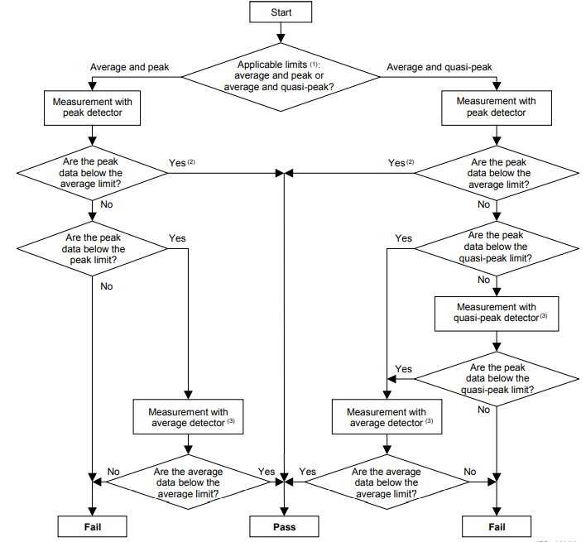

1. **Rod Antenna Setup**

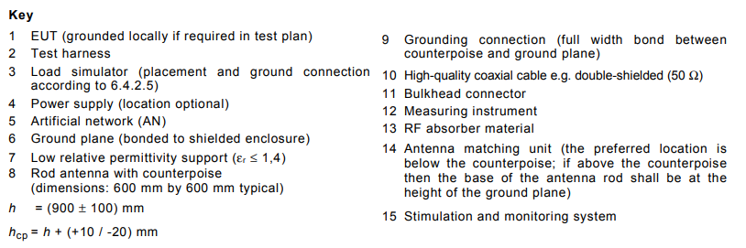

1. **Biconical Antenna Setup**

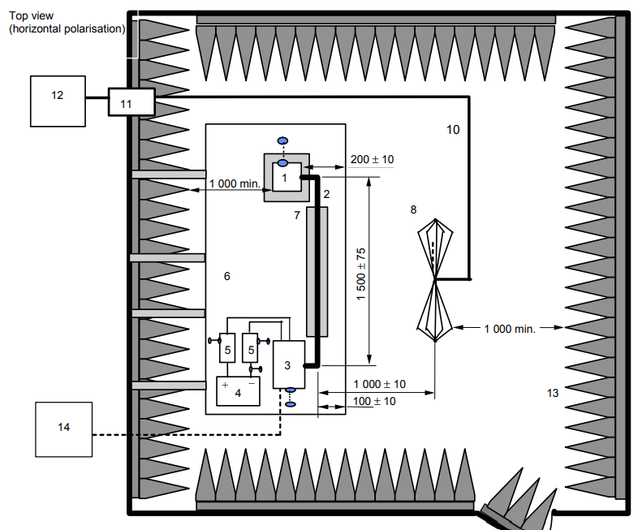

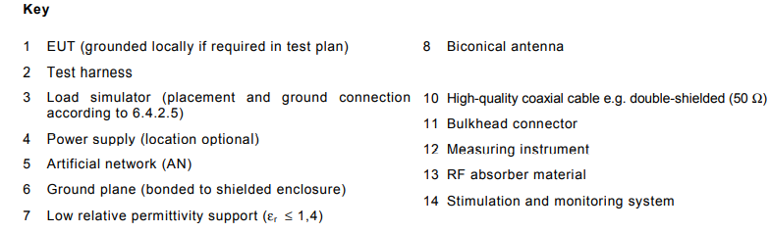

1. **Log-periodic Antenna Setup**

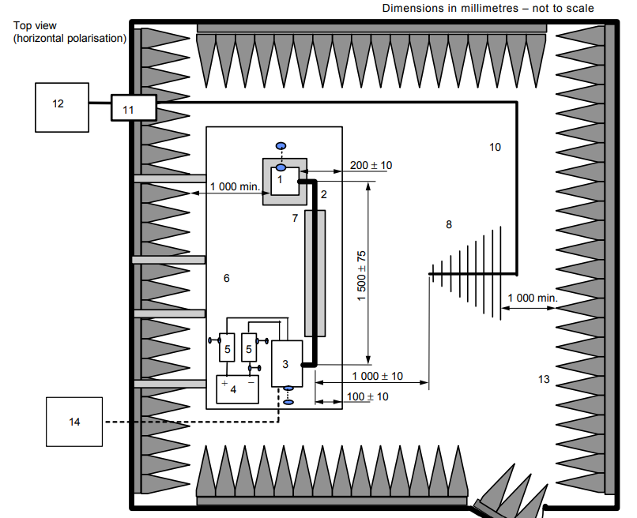

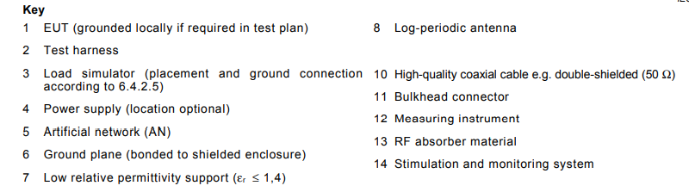

1. **Horn Antenna Setup**

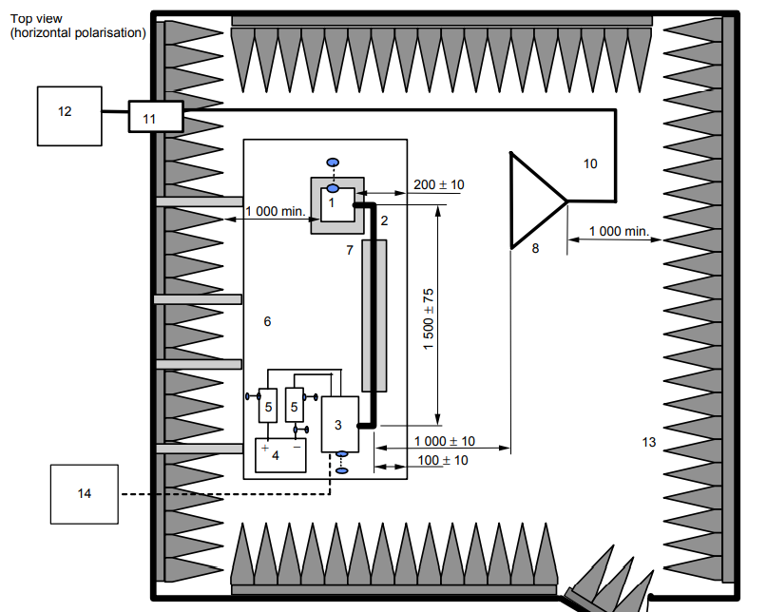

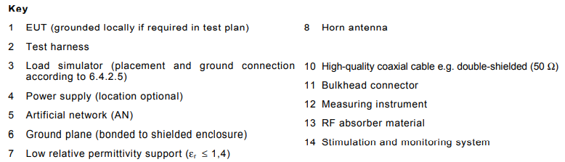

**14.1.6 Radiation Emission Limits:  
  
The test limits for the Radiated emission must be as per standard cispr25.  
Refer the below details for the same**

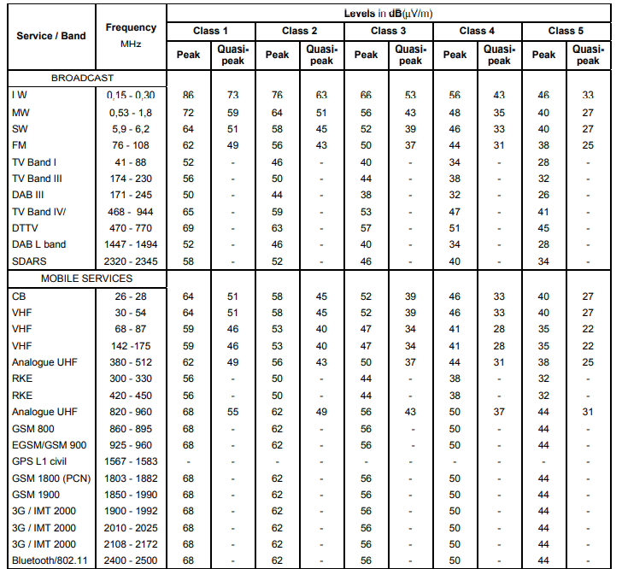

## Conducted Emissions - Voltage on Power leads

Test Specification reference: CISPR-25 Section 6.3

Acceptance Criteria: DUT shall meet CISPR 25 Section 6.3 table 5 Class 4 as a minimum.

**Purpose:**

- To test the effects of electromagnetic fields generated from electrical/electronic components and sub-systems applied to vehicles on the receiver installed in vehicles or peripheral components and external environment (surrounding facilities and vehicles)

- Conducted Emission Voltage Method is a test measuring the conducted noise radiated from the power and ground line of the electrical/electronic components and systems at the monitoring port of artificial network. (AN)

- This test can be applied to verify the characteristics of noise radiated from only a power line and a return line (a ground line).

**Reference Document:**

: CISPR-25 Section 6.2

**Ground plane arrangement**

**Test set-up**

* **Location of the EUT**

The EUT shall be placed on a non-conductive, low relative permittivity material (εr ≤ 1,4), at

(50 ±5) mm above the ground plane.

The case of the EUT shall not be grounded to the ground plane unless it is intended to

simulate the actual vehicle configuration.

All sides of the EUT shall be at least 100 mm from the edge of the ground plane. In the case

of a grounded EUT, the ground connection point shall also have a minimum distance of

100 mm from the edge of the ground plane.

* **Location of the test harness**

The power supply line(s) between the connector of the AN(s) and the connector(s) of the EUT

(*l*p) shall have a standard length of ( 200 +200 0 )mm.

The harness shall be placed in a straight line on a non-conductive, low relative permittivity

material (εr ≤ 1,4), at (50 ± 5) mm above the ground plane.

If, for particular EUTs (multi-connectors, special connectors, etc.), this standard length for the

power supply line(s) cannot be met, the minimum necessary length to be used shall be

defined in the test plan. This minimum length shall satisfy the requirement of *f*c ≥ 108 MHz, or

the measurements shall be limited to *f*c.

The following equation defines *f*c :

*f*c ≈ 30 / *l*P (2)

where

*f*c is the frequency in MHz

*l*p is the length in m

(This equation is based on *l*p ≤ λmin / 10).

To minimize the coupling between power and input/output leads, the space between those

lead types shall be maximized (≥ 200 mm from or perpendicular to the power supply lines

connecting the AN(s) and the EUT).

The total length of the test harness (excluding power lines) shall not exceed 2 m. The wiring

type is defined by the actual system application and requirement.

All leads and cables shall be located at a minimum distance of 100 mm from the edge of the

ground plane.

* **Location of the load simulator**

Preferably, the load simulator shall be placed directly on the ground plane. If the load

simulator has a metallic case, this case shall be bonded to the ground plane.

NOTE Alternatively, the load simulator may be located adjacent to the ground plane (with the case of the load simulator bonded to the ground plane) or outside of the test chamber, provided the test harness from the EUT passes through an **RF boundary** bonded to the ground plane.

When the load simulator is located on the ground plane, the d.c. power supply lines of the

load simulator shall be connected directly to the power supply and not through the AN(s).

**Test procedure**

The general arrangement of the disturbance source (EUT), connecting harnesses, etc.

represents a standardised test condition. Any deviations from the standard test harness

length, etc. shall be agreed upon prior to testing and recorded in the test report.

The EUT shall be made to operate under typical loading and other conditions as in the vehicle such that the maximum emission state occurs. These operating conditions must be clearly defined in the test plan to ensure supplier and customer perform identical tests.

– For EUT remotely grounded (vehicle power return line longer than 200 mm), the voltage

measurements shall be made on each lead (supply and return) relative to the ground

plane.

– For EUT locally grounded (vehicle power return line 200 mm or shorter), voltage measurements

on power supply leads shall be made relative to the ground plane.

– Generators/alternators shall be loaded with a battery and parallel resistor combination,

and connected to the artificial network in the manner shown in Figure 8. The load current,

operating speed, harness length and other conditions shall be defined in the test plan.

The conducted emissions on power lines are measured successively on positive power supply

and power return by connecting the measuring instrument on the measuring port of the related AN, the measuring port of the AN in the other supply lines being terminated with a 50 Ω load.

NOTE For EUT's with multiple positive power supply connections and/or multiple power return connections, the measurements (on power supply and on power return) may be performed with all power supply connections tied together at the AN and all power return connections tied together at the other AN.

The configuration shall be defined in the test plan.

For voltage measurements, the arrangement of the EUT and measuring equipment shall be as

shown in Figures , 6, 7 8 and 9 depending on the intended EUT installation in the vehicle.

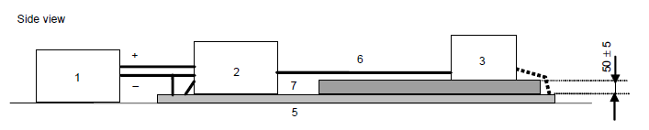

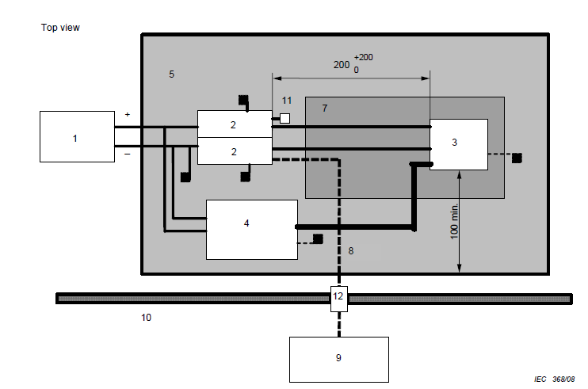

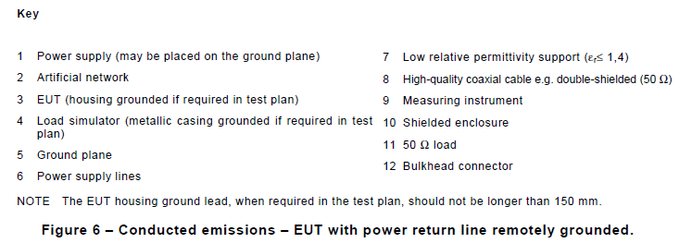

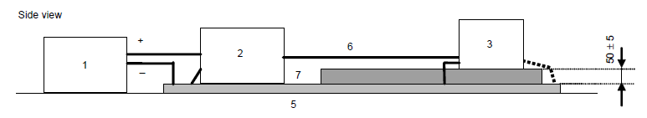

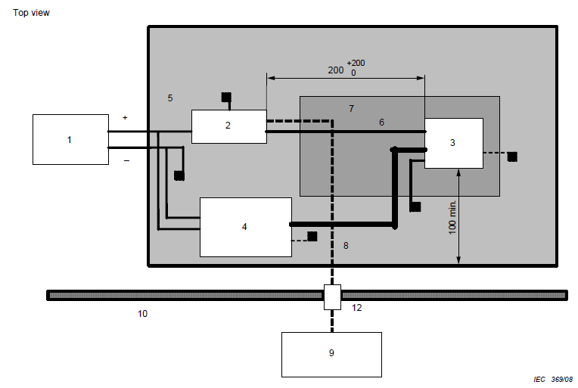

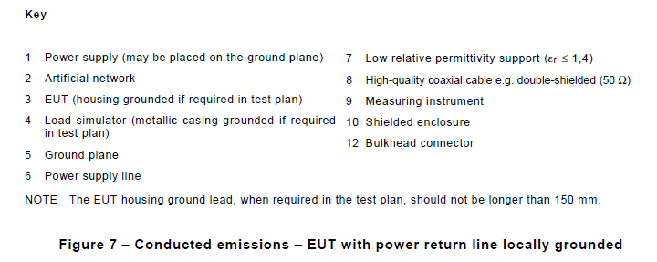

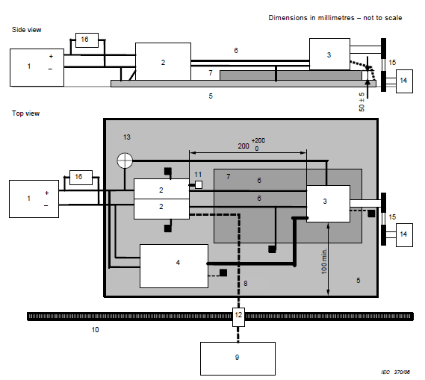

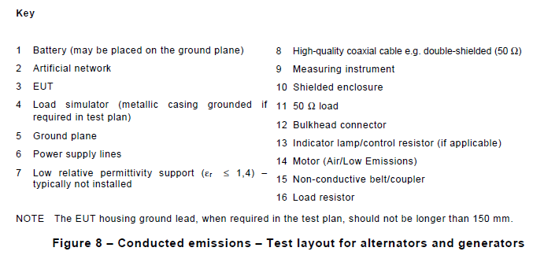

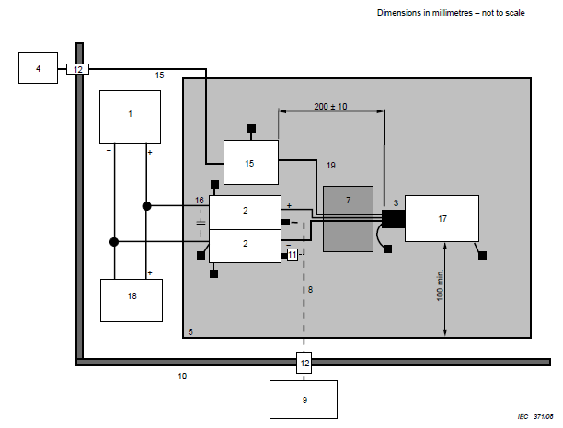

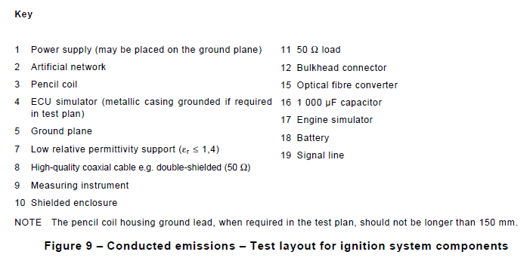

**Limits:**

The level class to be used (as a function of the frequency band) shall be agreed upon between the vehicle manufacturer and the component supplier. When using the provided limits, no correction factors for the AN shall be used.

NOTE It is recommended for acceptable radio reception in a vehicle that the conducted noise should not exceed

the values shown in Tables 5 and 6, peak and average or quasi-peak and average, respectively. Since the .mounting location, vehicle body construction and harness design can affect the coupling of radio disturbances to

the on-board radio, multiple limit levels are defined.

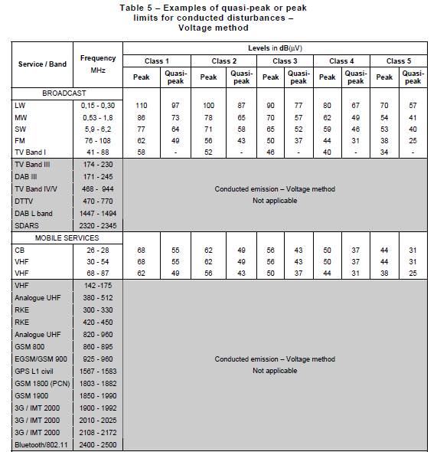

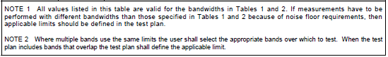

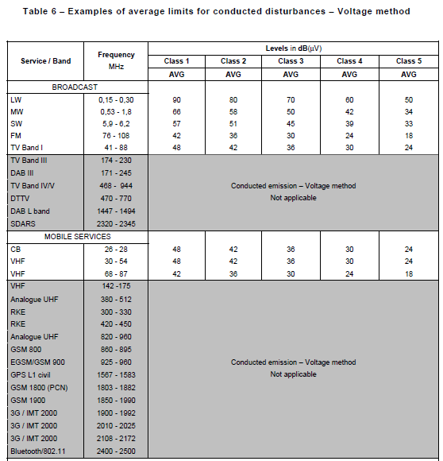

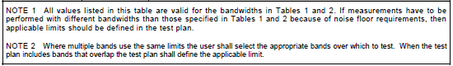

## Conducted Emissions - Current probe on cable harness

Test Specification reference: CISPR-25 Section 6.4

Acceptance Criteria: DUT shall meet CISPR 25 Section 6.4 table 6 Class 4 as a minimum

## Interference immunity - BCI on cables

Test Specification reference: ISO 11452-4

Acceptance Criteria: DUT shall be tested up to level 4, meet Test level 2 with FPSC status 1 as a minimum.

**Purpose**

The purpose of this test to verify the immunity against electromagnetic interferences of electrical/electronic components by introducing noise/disturbance signals(Continuous narrowband electromagnetic fields) directly to the wiring harness by means of current injection probe. And test the components whether any malfunctions ae present.

**Reference Documents**

ISO11452 – 1 : 2015 : Section

ISO11452 – 4 : 2020 : Section

**Test Setup**

* **Ground plane**

The ground plane shall be made of 0,5 mm thick (minimum) copper, brass or galvanized steel.

The minimum width of the ground plane shall be 1 000 mm. The minimum length of the ground plane shall be 1 500 mm, or the length of the entire underneath of the equipment plus 200 mm, whichever is the larger.

The height of the ground plane (test bench) shall be (900 ± 100) mm above the floor.

The ground plane shall be bonded to the shielded enclosure such that the d.c. resistance shall not exceed 2,5 mΩ. In addition, the bond straps shall be placed at a distance no greater than 0,3 m apart.

* **Power supply and AN**

Each DUT power supply lead shall be connected to the power supply through an AN.

Power supply is assumed to be negative ground. If the DUT utilizes a positive ground then the test set-ups shown in the figures need to be adapted accordingly. Power shall be applied to the DUT via a 5 μH/50 Ω AN(see Annex C for the schematic). The number of ANs required depends on the intended DUT installation in the vehicle.

--- For a remotely grounded DUT (vehicle power return line longer than 200 mm), two ANs are required: one for the positive supply line and one for the power return line (see Annex D).

--- For a locally grounded DUT (vehicle power return line 200 mm or shorter): one AN is required for the positive supply (see Annex D).

The AN(s) shall be mounted directly on the ground plane. The case or cases of the AN(s) shall be bonded to the ground plane.

The power supply return shall be connected to the ground plane — between the power supply and the AN(s).

The measuring port of each AN shall be terminated with a 50 Ω load.

* **Location of DUT**

The DUT shall be placed on a non-conductive, low relative permittivity (dielectric-constant) material ( εr ≤ 1,4),at (50 ± 5) mm above the ground plane.

The case of the DUT shall not be grounded to the ground plane unless it is intended to simulate the actual vehicle configuration.

The face of the DUT shall be located at least 100 mm from the edge of the ground plane.

There should be a distance at least 500 mm between the DUT and any metal part such as the walls of the shielded enclosure, with the exception of the ground plane on which the DUT is placed.

* **Location of test harness**

The total length of the test harness between the DUT and the load simulator (or the RF boundary) shall be (1 000 ± 100) mm, unless otherwise specified in the test plan.

The wiring type is defined by the actual system application and requirement.

The test harness should be straight over its whole length and of fixed (position and number of wires)

composition. It should pass through the current injection and current measurement probes. The length of the wires in the simulator should be short by comparison with the length of the harness. The wires within the simulator should be anchored.

The test harness shall be placed on a non-conductive, low relative permittivity (dielectric-constant) material (εr ≤ 1,4), at (50 ± 5) mm above the ground plane.

* **Location of load simulator**

Preferably, the load simulator shall be placed directly on the ground plane. If the load simulator has a metallic case, this case shall be bonded to the ground plane.

Alternatively, the load simulator may be located adjacent to the ground plane (with the case of the load

simulator bonded to the ground plane) or outside of the test chamber, provided the test harness from the DUT passes through an RF boundary bonded to the ground plane.

When the load simulator is located on the ground plane, the d.c. power supply lines of the load simulator shall be connected through the AN(s).

* **Location of current probe(s)**
* **Substitution method**

The injection probe shall be placed at the following distances, d, from the connector of the DUT:

--- d = (150 ± 10) mm;

--- d = (450 ± 10) mm;

--- d = (750 ± 10) mm.

If a current measurement probe is used during the test it shall be placed at (50 ± 10) mm from the connector of the DUT.

* **Closed-loop method with power limitation**

The injection probe shall be placed at (900 ± 10 ) mm from the connector of the DUT.

The current measurement probe shall be placed at (50 ± 10) mm from the connector of the DUT.

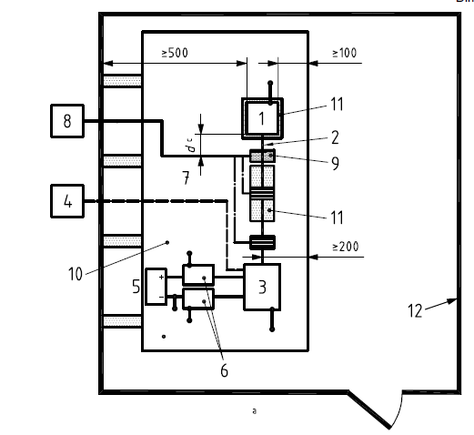

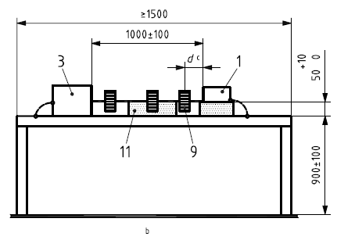

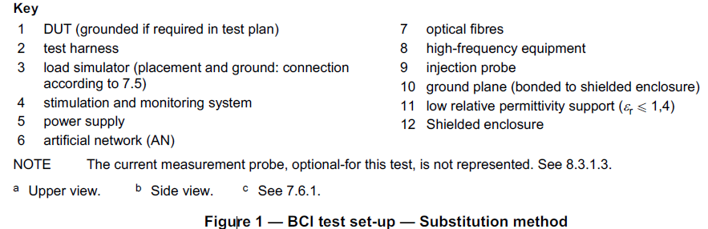

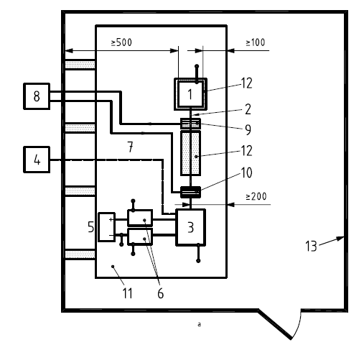

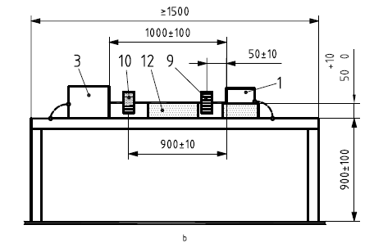

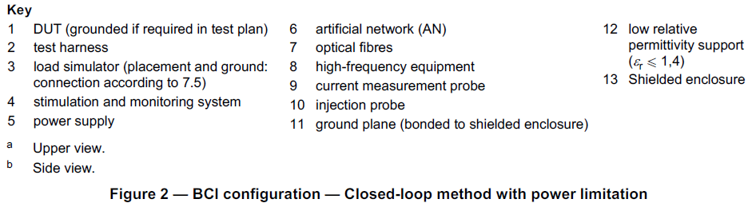

**Test Procedure**

* **Substitution method**
* **General**

The substitution method is based upon the use of forward power as the reference parameter for calibration and testing.

The method is carried out in two phases:

a) calibration (on jig);

b) test of the DUT.

* **Calibration**

The specific test level (current) shall be calibrated periodically by recording the forward power required to produce a specific current measured on a 50 Ω calibration jig (see Annex A) for each test frequency. This calibration shall be performed with an unmodulated sinusoidal wave.

Include, upon request, the values of forward and reverse power recorded in the calibration file in the test report.

The calibration jig should be terminated by a 50 Ω (high-power) load at one end and by a 50 Ω RF power meter at the other end, protected by a 50 Ω attenuator of adequate power rating (see Annex A).

* **DUT test**

Install the DUT, harness and associated equipment on the test bench as shown in Figure 1.

Subject the DUT to the test signal based on the calibrated value as predetermined in the test plan.

A current measurement probe may be mounted between the current injection probe and the DUT. The use of a current measurement probe is optional; it can provide extra, useful information during investigative work on the cause of events and the variances in test conditions after system modifications. However, care should be taken, because the monitoring probe may affect the injected current.

* **Closed loop method with power limitation**
* **General**

The test method is based upon the use of the forward power as the reference parameter used for calibration and testing.

The method is carried out in two phases:

a) calibration (on jig);

b) test of the DUT.

The power limit is determined using a calibration jig.

The disturbance (Idisturb) applied to the DUT is determined using a limit curve versus frequency.

* **Calibration**

This procedure determines the power limit applicable for the test with DUT.

The specific test level (current) shall be calibrated prior to the actual testing (see Annex A).

Prior to the actual test with DUT, the forward power required to produce a specific current measured on a 50 Ω calibration jig (see Annex A) shall be determined for each frequency.

This calibration shall be performed with an unmodulated sinusoidal wave.

Include, upon request, the values of forward and reverse power recorded in the calibration file in the test report.

The calibration jig should be terminated by a 50 Ω (high-power) load at one end and by a 50 Ω RF power meter at the other end, protected by a 50 Ω attenuator of adequate power rating (see Annex A).

Apply the current test signal level to the jig and record the corresponding forward power (Pfor cal).

The power limit is calculated from:

PCW limit = kPfor cal

where

PCW limit is the power limit;

Pfor cal is the forward power applied to reach the current test signal level in the jig.

The default value for k is 4, unless otherwise specified in the test plan.

* **DUT Test**

Install the DUT, harness and associated equipment on the test bench as shown in Figure 2.

The test procedure uses a closed loop method with power limit (Plimit).

The procedure used at each frequency is described below.

Increase the forward power applied to the current injection probe and measure the injected current (Iref) until either

--- the measured current reaches the specified test level, or

--- the forward power reaches the power limit PCW limit.

In either case, record the achieved current (Iref) and the applied forward power (Pref).

When the DUT susceptibility threshold is found, the fault current (Ifault) and the forward power applied (Pfault) shall also be recorded.

When a harness containing several branches is used, repeat the test with the injection probe clamped around each branch, (900 ± 10) mm from the connector of the DUT. Under these test conditions, the current measurement probe, shall be left at its previous distance from the DUT.

## Interference Immunity - ALSE (Antenna)

Test Specification reference: ISO 11452-2

Acceptance Criteria: DUT shall be tested up to level 4, meet Test level 2 with FPSC status 1 as a minimum.

This will differ from the ECU to ECU. Hence system level operation, the supplier should get these details reviewed and get the written approval for the same.

**Purpose:**

The device under test (DUT), together with the wiring harness (prototype or standard test harness), is subjected to an electromagnetic disturbance generated inside an absorber-lined shielded enclosure, with peripheral devices either inside or outside the enclosure. It is applicable only to disturbances from continuous narrowband electromagnetic fields.

It will verify whether DUT will be able to sustain in such an electromagnetic disturbance.

Radiation will be generated by immunity antenna.

**Reference Documents:**

ISO 11452-2: Second edition 2004-11-01 ; Part 2

**Test Range:**

The applicable frequency range of the absorber-lined shielded enclosure test method is 80 MHz to 18 GHz.

**Test apparatus and instrumentation:**

Radiated electromagnetic fields are generated using antenna with a radio frequency (RF) energy source capable of producing the desired field strengths. A set of antennae and multiple RF amplifiers could be required to cover the range of test frequencies.

Measuring equipment:

* Field-generating device: any available antenna (including high-power baluns, if appropriate) capable of radiating the specified field strength at the DUT with the available power may be used.
* Field probes, which should be electrically small and isotropic.
* Artificial network(s)
* HF generator
* High-power amplifier
* Power meter

**Test set-up:**

**The test setup and details should comply with the requirements of ISO 11452-2 the standard.**

**Ground plane:** The ground plane shall be made of 0,5 mm thick copper. The minimum width of the ground plane shall be 1 000 mm.

The minimum length of the ground plane shall be 2 000 mm, or the length of the entire underneath of the equipment plus 200 mm, whichever is the larger.

The height of the ground plane (test bench) shall be (900 ± 100) mm above the floor. The ground plane shall be bonded to the shielded enclosure such that the d.c. resistance shall not exceed 2,5 mΩ. In addition, the bond straps shall be placed at a distance no greater than 0,3 m apart edge to edge.

**Power supply and AN:** Each DUT power supply lead shall be connected to the power supply through an AN.

The AN(s) shall be mounted directly on the ground plane. The case or cases of the AN(s) shall be bonded to the ground plane.

The power supply return shall be connected to the ground plane — between the power supply and the AN(s).

**Location of DUT:** The DUT shall be placed on a non-conductive, low relative permittivity (dielectric-constant) material (εr u 1,4), at (50 ± 5) mm above the ground plane.

**Location of test harness:** The part of the test harness parallel to the front edge of the ground plane shall be (1500 ± 75) mm.

The total length of the test harness between the DUT and the load simulator (or the RF boundary) shall not exceed 2 000 mm. The wiring type is defined by the actual system application and requirement.

**Location of load simulator:** the load simulator shall be placed directly on the ground plane. If the load simulator has a metallic case, this case shall be bonded to the ground plane.

**Location of field generating device (antenna):** The height of the phase center of the antenna shall be (100 ± 10) mm above the ground plane. No part of any antenna radiating element shall be closer than 250 mm to the floor.

The distance between the wiring harness and the antenna shall be (1 000 ± 10) mm.

This distance is measured from.

* the phase center (mid-point) of the biconical antenna,
* the nearest part of the log-periodic antenna,
* the nearest part of the horn antenna.

The phase center of the antenna for frequencies from 80 MHz to 1 000 MHz shall be in line with the center of the longitudinal part (1 500 mm length) of the wiring harness. The phase center of the antenna for frequencies above 1 000 MHz shall be in line with the DUT.

**Test procedure:**

**The test procedure and details should comply the requirements of the ISO11542-2 standard**.

The test shall be performed with the substitution method, which is based upon the use of forward power as the reference parameter used for field calibration and test.

This method is carried out in two phases:

1. field calibration (without the DUT, wiring harness and peripheral devices present)
2. test of the DUT with wiring harness and peripheral devices connected.

**Field calibration:**

Place the electrical phase center of the field probe (150 ± 10) mm above the ground plane and at a distance of (100 ± 10) mm from the front edge of the ground plane.

* For frequencies of from 80 MHz to 1 000 MHz, the phase center of the field probe shall be in line with the center of the longitudinal part (1 500 mm length) of the wiring harness position.
* For frequencies above 1 000 MHz, the phase center of the field probe shall be in line with the DUT position.

Place the field-generating device (antenna) at a distance of (1 000 ± 10) mm from the electrical phase center of the field probe. Calibrate the field strength for vertical and horizontal polarizations.

When requested, the values of forward and reverse power recorded in the calibration file and a precise description of the associated position of the field probe shall be included in the test report.

**DUT test:**

Install the DUT, harness and associated equipment on the test.

Subject the DUT to the test signal based on the calibrated value as predetermined in the test plan.

A field probe may be placed above the wiring harness during the test.

Perform the test for both horizontal and vertical polarization in the appropriate frequency ranges.

**Biconical Antenna:**

**LOG-Periodic Antenna:**

**Horn Antenna:**

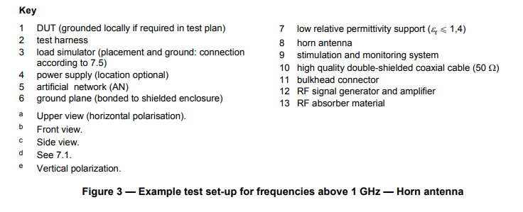

**Function performance status classification (FPSC):**

## Interference Immunity – Magnetic Fields

Test Specification reference: ISO 11452-8

Acceptance Criteria: DUT shall be tested up to level 4, meet minimum requirement of Status I at level 2. FPSC as described in ISO 11452-1: Status I-The function performs as designed during and after the test.

This will differ from the ECU to ECU. Hence system level operation, the supplier should get these details reviewed and get the written approval for the same.

**Purpose:**

This test is to check the immunity and Performance of the Electrical components under magnetic field disturbance.

These sources are classified into “internal magnetic field” (sources internal to the vehicle, e.g. vehicle electro-mechanical motors, actuators,) and “external magnetic field” (sources external to the vehicle e.g. power transmission lines, generating stations,). To perform this test, the device under test (DUT) is exposed to a magnetic disturbance field.

**References Documents:**

ISO 11452-8: Second edition 2015-06-01; Part 8

**Test Frequency:**

The applicable frequency range of this test method is d.c. and 15 Hz to 150 kHz.

**Test Setup:**

**The test setup and details should comply with the requirements of the ISO 11452-8 standard.**

* The test area should be of a suitable size to house all the required test equipment and shall be free from disturbances that might affect the test results.
* The magnetic field generator (radiating loop or Helmholtz coil) should be at least 2 m away from the DUT monitoring equipment.
* The magnetic field generator shall be maintained at a minimum of 1 m from metal surfaces parallel to the plane of the coil(s).

**Location of the test harness and DUT:**

* The test harness shall be designed in order to minimize different coupling effects inside the harness (e.g., twisted pairs) and to minimize interference to the load box and power supply.
* Radiating loop method:
* Each face of the DUT shall be partitioned into equal areas of 100 mm × 100 mm or less.
* The radiating loop shall be positioned 50 mm from the center of each of these areas and parallel to the face of the DUT.
* the radiating loop shall be placed at each electrical interface connector and at any attached magnetic sensor(s). The radiating loop shall be placed so that maximum coupling occurs between it and any attached magnetic sensor(s).

**Please refer the below figure for more detail.**

**Helmholtz coil method:**

* The DUT shall be positioned in one of its three principal axes (X, Y, and Z) on a non-conducting, lowpermeability (μr approximately 1) material into the uniform field region of the Helmholtz coil.
* If possible, the actual loads and actuators shall be used. Power may be applied to the DUT via a 5 µH/50 Ω artificial network.

**Please refer below figure for more detail:**

**Test procedure:**

**The test procedure and details should comply with the requirements of the ISO 11452-8 standard.**

There are two test methods:

* + - 1. Radiation loop method.
      2. Helmholtz coil method.

1. **Radiation loop method.**

The test shall be performed with verification at d.c. and at one additional frequency and based upon the use of coil current as the reference parameter used for field verification and test.

This method is carried out in the following two phases:

a) field verification at d.c. and at one additional frequency (without the DUT, wiring harness, and peripheral devices present);

b) test of the DUT with wiring harness and peripheral devices connected.

**Verification:**

The specific test level (field) shall be verified periodically at one frequency (e.g., 1 kHz) and d.c. by recording the coil current required to produce a specific field strength, measured with a field probe. This verification shall be performed with an unmodulated sinusoidal wave.

**DUT test:**

The test is conducted by subjecting the DUT to the test signal based on the calculated value as defined in the test plan. The test shall be performed with the three-axial polarization.

**DUT test:**

The test is conducted by subjecting the DUT to the test signal based on the calculated value as defined in the test plan. The test shall be performed with the three-axial polarization.

1. **Helmholtz coil method**

This method is carried out in the following two phases:

* field verification (without the DUT, wiring harness, and peripheral devices present.
* test of the DUT with wiring harness and peripheral devices connected.

**Verification** The specific test level (field) shall be verified periodically by recording the coil current required to produce a specific field strength, measured with a field probe, for each test frequency.

This verification shall be performed with an unmodulated sinusoidal wave.

**DUT test:**

The test is conducted by subjecting the DUT and the associated harness to the test signal based on the calibrated value as predetermined in the test plan. Place the operating DUT in the uniform field region of the Helmholtz coil.

At each frequency, expose the DUT and the associated harness for a minimum of 1 s. In case of any malfunction of the DUT, the corresponding frequency and field intensity shall be recorded. Repeat the above steps for the other two orientations (X, Y, or Z axes) of the DUT.

## Conducted Transient on power lines

Test Specification reference: ISO 7637 - 2 Section 4.3

Acceptance Criteria: DUT shall meet level IV of table B.2 as well as ECE #10 and Hyundai section 7.3.7

This will differ from the ECU to ECU. Hence system level operation, the supplier should get these details reviewed and get the written approval for the same.

**Purpose:**

This test is e for evaluating the automotive electrical and electronic components of the device under test (DUT), considered a potential source of conducted disturbances, for conducted emissions of transients along the battery-fed or switched supply lines.

**References Documents:**

ISO 7637 – 2: Second edition 2004-06-15; section 4.3

**Test Frequency:**

1. Slow pulses (millisecond range or slower)
2. Fast pulses (nanosecond-to-microsecond range)

**Test Setup:**

**The test setup and details should comply with the requirements of ISO 7637 – 2 the standard.**

* Voltage transients from the disturbance source, the DUT, are measured using the artificial network to standardize the impedance loading on the DUT. The disturbance source is connected via the artificial network to the shunt resistor, Rs, the switch, and the power supply.
* All wiring connections between artificial network, switch, and the DUT shall be spaced 50 mm above the metal ground plane.
* The cable sizes shall be chosen in accordance with the real situation in the vehicle, i.e., the wiring shall be capable of handling the operating current of the DUT, and as agreed between vehicle manufacturer and supplier.
* If no requirements are specified in the test plan, then the DUT shall be placed on a non-conductive material 50 mm above the ground plane.
* The disturbance voltage shall be measured as close to the DUT terminals as possible, using a voltage probe and an oscilloscope or waveform acquisition equipment.
* Repetitive transients shall be measured with the switch S closed. If the transient is caused by a supply disconnection, measurement shall be started at the moment of opening switch S.
* See the below figures to get clean picture of setup.

**Test Procedure:**

**The test procedure and details should comply the requirements ISO 7637 – 2 of the standards.**

Please refer the below test procedure, test setup images to be followed according to the standard, for the below tests.

* DUT operating conditions of particular interest in the measurements are the turn on, the turn off, and the exercising of the various operating modes of the DUT. The exact operating conditions of the DUT shall be specified in the test plan.
* The sampling rate and trigger level shall be selected to capture a waveform displaying the complete duration of the transient, with sufficient resolution to display the highest positive and negative portions of the transient.
* Utilizing the proper sampling rate and trigger level, the voltage amplitude shall be recorded by actuating the DUT according to the test plan.
* Other transient parameters, such as rise time, fall time and transient duration, may also be recorded. Unless otherwise specified, ten waveform acquisitions are required.
* Only those waveforms with the highest positive and negative amplitude (with their associated parameters) shall be recorded. The measured transient shall be evaluated.
* All pertinent information and test results shall be reported. If required per the test plan, include transient evaluation results with respect to the performance objective as specified in the test plan.

**Essential elements of transient emissions waveform characteristics:**

**Transient waveform classification table:**

**Below mentions limits are as per the ISO 7637 – 2 Standards.**

## Conducted Immunity to Transient on power lines

Test Specification reference: ISO 7637 - 2 Section 4.4

Acceptance Criteria: DUT AV shall be tested up to level 4for pulse 1, 2a, 2b, 3a and 3b, meet minimum requirement of Status I at level 2. The function performs as designed during and after the test.

This will differ from the ECU to ECU. Hence system level operation, the supplier should get these details reviewed and get the written approval for the same.

**Purpose:**

These tests are for measuring the transient emission on supply lines and the immunity of devices against such transients.

Testing the compatibility to conducted electrical transients of equipment installed on passenger cars and light commercial vehicles fitted with a 12 V electrical system or commercial vehicles fitted with a 24 V electrical system — for both injection and the measurement of transients.

**References Documents:**

ISO 7637-2: Second edition 2004-06-15; part 2

**Test setup:**

**The test setup and details should comply with the requirements of the ISO 7637-2 standard.**

To follow the test setup please refer the below figure:

**Test Procedure:**

**The test procedure and details should comply the requirements ISO 7637 – 2 of the standards.**

* For test pulses 3a and 3b, the leads between the terminals of the test pulse generator and the DUT shall be laid out in a straight parallel line at a height of 50 mm above the ground plane and shall have a length of (0,5 ± 0,1) m.
* For correct generation of the required test pulses, it may be necessary to switch the power supply on and off. The switching can be performed by the test pulse generator if the power supply is integral to it.
* One way to simulate the waveform of an alternator with centralized load dump suppression (see Figure 12), is to connect a suppression diode (or diode bridge) across the output terminals of the test pulse generator [see Figure 2 a) and b].
* Since a single diode will generally have part-to-part variation and may not be able to handle the large alternator currents, the use of a bridge arrangement [an example is shown in Figure 2 c)] is recommended.
* The same generator shall be used for test pulses 5a and 5b. The suppression diodes and the suppressed voltage levels (clamping voltage) used by different car manufacturers are not standard.
* The supplier (parts manufacturers) must, therefore, obtain the diode and clamping voltage specification information from the manufacturer to be able to perform this test.
* The single diodes are added to the diode bridge as needed to provide the specified clamping voltage.

**Test Pulse 1:**

**Test pulses 2a and 2b:**

**Test pulses 3a and 3b:**

**Test pulse 4:**

**Test pulses 5a and 5b:**

## Coupled Transient Interference on cable harness

Test Specification reference: ISO 7637 - 3

Acceptance Criteria: DUT shall be tested up to level 4, meet minimum requirement of Status I at level 2. The function performs as designed during and after the test.

## Powered Electrostatic Discharge (ESD)

Test Specification reference: EN 61000- 4-2/ISO 10605 section 8

Up to +/-8KV contact or +/-15KV air discharge to accessible parts during operation. Debug ports are included.

Acceptance Criteria: DUT shall meet Status I: The function performs as designed, during and after the test.

**Purpose:**

The purpose of this test to check the powered Eletrostatic Discharge of the simulator used to generate the electrostatic discharges, as well as functional status classifications for immunity to ESD.

**Reference Document:**

ISO 10605:2001

**Test Procedure:**

* **General**

Prior to performing the test, generate a test plan that includes interface test points, electronic module mode of operation and any special instructions and changes from the standard test.

Before applying any discharges to the device under test, verify that the ESD simulator discharge verification procedure of annex A has been performed within the time period established by the laboratory or the customer.

For the test of electronic modules, use the 330 pF capacitor probe.

* **Test**
* **General**

Maintain the ambient temperature during the test at (23 ± 5) °C and the relative humidity between 30 % and 60 % (20 °C and 30 % relative humidity is preferred), or using other values agreed to by the user, in which case such values shall be documented in the test report.

Set up the test in accordance with Figure 3.

Connect the ESD simulator high-voltage ground directly to the ground plane by a grounding strap as in 4.3 and Figure 3.

Place the device under test on the ground plane (see Figure 3). Place the chassis-mounted electronic modules directly on, and connect them to, the ground plane. Test electronic modules isolated from ground in normal installation with an insulator between the electronic module and the ground plane using insulation blocks (4.4). Connect all voltage supply pins to an appropriate power source. Provide inputs for all other pins as necessary to put the device under test into a simulated mode of operation.

Ensure that the device under test is at least in a powered, idling mode.

Test each exposed shaft, button, switch or surface of the device under test accessible to an occupant inside the vehicle, at each of the voltage levels defined in annex B or as specified in the test plan, in accordance with 5.2.2 and 5.2.3.

Subject each discharge point to a minimum of three positive polarity and three negative polarity discharges at each voltage level, with a minimum time duration between discharges of 5 s.

At each voltage level, all discharge points of a device may be tested first at a single polarity and then with the opposite polarity.

During and after each series of three discharges, verify that the device under test meets all applicable performance requirements.

4) The measurement is to be made on a square piece of material that can be any dimension [m2, mm2, (0,5 m)2]. Surface resistivity is defined as follows: for an electric current flowing across a surface, the ratio of d.c. voltage drop per unit length to the surface current per width. In effect, the surface resistivity is the resistance between two opposite sides of a square and is independent of the size of the square or its dimensional units. Surface resistivity is expressed in ohms per square.[1]

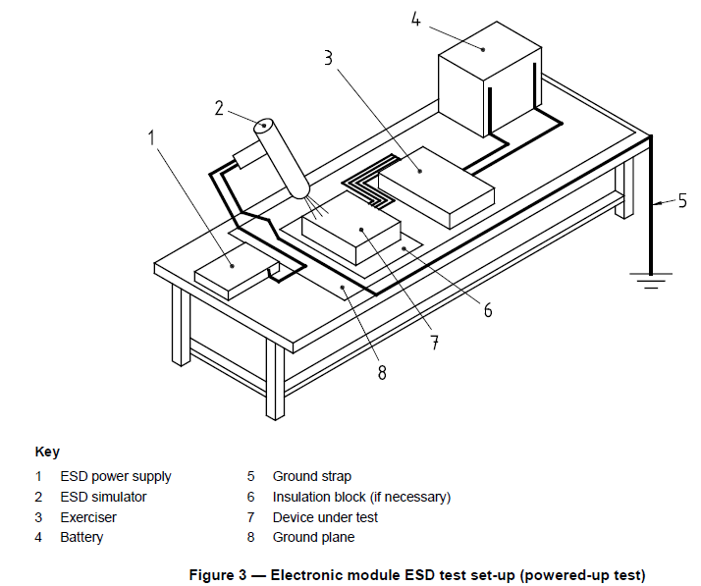

* **Direct contact discharge**

Using the direct contact discharge probe [Figure 2 b)], place the ESD simulator in direct contact with all accessible discharge points and test each discharge point to the contact discharge voltage levels given in Table B.1.

* **Air discharge**

Using the air discharge probe [Figure 2 a)], place the ESD simulator a minimum of 15 mm away from the device under test. Hold the simulator fingertip probe perpendicular (± 15°) to the discharge location and move it very slowly, i.e. at u 5 mm/s, towards the device under test until a single discharge is obtained. Test each point to the air discharge voltage levels in Table B.1.

If no discharge occurs, continue moving the probe towards the device under test until the simulator discharge tip is in contact with the discharge point. If still no discharge occurs, discontinue testing at that voltage level and location.

* **Requirement**

The functional status of the device under test shall be as agreed upon on the basis of annex B of the standard document.

## Handling Electrostatic Discharge (ESD)

Test Specification reference:  ISO 10605 Section 9

Handling ESD while the unit is unpowered.   
Direct ESD: +/- 8KV contact or +/- 15KV air discharge.

Acceptance Criteria: DUT shall pass complete function testing successfully after testing has been performed. There shall be no permanent damage.

**Purpose:**

The purpose of this test to check Handling of the simulator used to generate the electrostatic

discharges, as well as functional status classifications for immunity to ESD.

**Reference Document:**

ISO 10605:2001

**Electronic module sensitivity classification for packaging and handling (unpowered**

**test)**

* **General**

Prior to performing the test, generate a test plan that includes interface test points, electronic module mode of operation, number of modules to be tested, and any special instructions and changes from the standard test.

Before applying any discharges to the device under test, verify that the ESD simulator discharge verification procedures of annex A have been performed within the time period established by the laboratory or the customer.

All containers of ESD-sensitive devices and, where required, the ESD-sensitive devices themselves shall be clearly marked with a standard ESD warning label.

For the packaging and handling test, the ESD simulator shall be configured with the 150 pF capacitor probe shown in Figure 1 b).

Maintain the ambient temperature during the test at (23 ± 5) °C and the relative humidity at between 30 % and 60 % (20 °C and 30 % RH is preferred), or using other values agreed to by the user, in which case such values shall be documented in the test report.

* **Tests**
* **Full functional test**

Perform a full functional test of the device under test (checking for rise time, current leakage, etc.) prior to any application of ESD. The functional status of the device under test shall be class A (see annex B).

* **ESD test**
* **General**

Disconnect the device under test from its power supply. Configure the test set-up according to Figure 5.

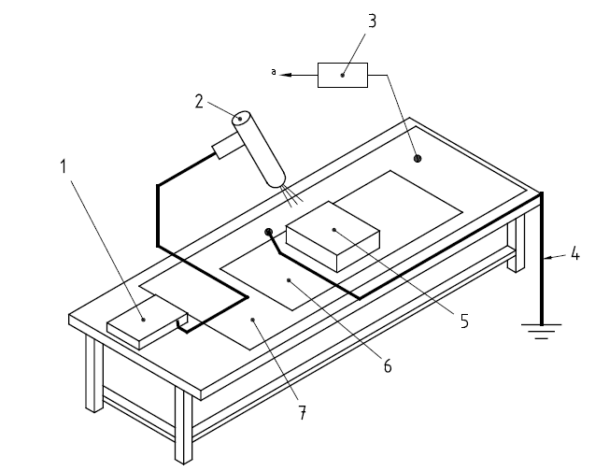

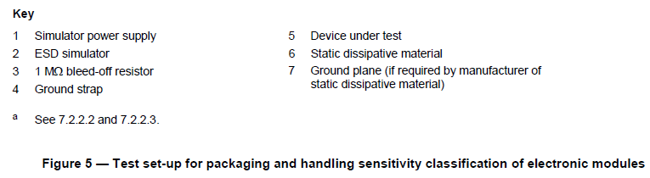

Connect the ESD simulator high voltage ground directly to the ground plane (if used) or to ground by a grounding strap as specified in 4.3.

Place the device under test on a static dissipative material as specified in 4.9 to bleed-off any accumulated charge from the (device under test) housing.

Step-stress the device under test according to the test levels shown in Table B.3.

Apply the ESD at, but not limited to, each connector pin, case, button, switch display, case screw, and case opening of the device under test that is accessible during handling. For this procedure, recessed connector pins are considered accessible during handling.

Use an insulated solid (not stranded) wire with a cross-sectional area of between 0,5 mm2 and 2 mm2 and a length of ≤ 25 mm to access recessed connector pins.

NOTE Modules that have recessed pins in metallized grounded connector bodies where the pins are not easily accessible (e.g. with a finger) need not be tested.

A connector with closely-spaced pins may result in a crowding of the lead wires, making it difficult to discharge the intended wire. If this occurs, use multiple connectors with a reduced number of lead wires in each. Evaluate each connector configuration separately.

* **Direct contact discharge**

Place the ESD simulator in direct contact with all selected discharge points and test at the direct contact discharge voltages specified in Table B.3 using the direct contact discharge probe of Figure 2 b). After each discharge to the device under test, residual charge remaining on the device under test shall be drained by briefly connecting a 1 MΩ resistor (see Figure 5) in the following sequence:

1. between the discharge location and ground;
2. between the ground point of the device under test and ground.

A minimum of six discharges shall be applied to each test point at each voltage level: three with a positive polarity and three with a negative polarity.

* **Air discharge**

Test each discharge point at the air discharge voltages specified in Table B.3 using the air discharge probe of Figure 2 a). Place the ESD simulator a minimum of 15 mm from the device under test. Place the simulator air discharge probe perpendicular (± 15°) to the discharge location. Move it very slowly, i.e. u 5 mm/s, towards the device under test until a single discharge is obtained. After each discharge to the device under test, residual charge remaining on the device under test shall be drained by briefly connecting a 1 MΩ resistor (see Figure 5) in the following sequence:

1. between the discharge location and ground;
2. between the ground point of the device under test and ground.

A minimum of six discharges shall be applied to each test point at each voltage level: three with a positive polarity and three with a negative polarity.

If no discharge occurs, continue moving the probe towards the device under test until the simulator discharge probe contacts the discharge point. If still no discharge occurs, discontinue testing at that voltage level and location.

When testing inaccessible points (non-connector), slowly move the probe tip close enough to generate a discharge. Points shall be considered inaccessible when the ESD simulator probe cannot touch them directly.

* **Requirements**

After discharging to all the points of the device under test at one of the specified positive and negative voltage levels (after each positive and negative voltage level), the device under test shall meet all applicable functional tests. The functional status shall be as agreed upon on the basis of annex B of standard document.

It is recommended that all devices under test survive ± 4 kV direct contact discharge, otherwise they may be difficult to protect against ESD damage due to handling.

# References

## Industry Standards

|  |  |
| --- | --- |
| Standards | Description |
| **CISPR-25:2016** | Emission Control |
| **ISO 11452** **–** **4:2011** | Interference Immunity – BCI |
| **ISO 11452** **–** **2:2019** | Interference Immunity – Antenna |
| **ISO 11452** **–** **9:2012** | Interference Immunity – Portable Transmitters |
| **ISO 11452** **–** **8:2015** | Interference Immunity – Magnetic Fields |
| **ISO 7637** **–** **2:2011** | Conducted Immunity |
| **ISO 7637** **–** **3:2016** | Coupled Interference |
| **DIN EN 61000-4-2:2008/ISO 10605:2008** | ESD |
|  |  |

## Motional Requirements

## Acronyms and Terms

|  |  |
| --- | --- |
| Acronym or Term | Definition |
| **ALSE** | Absorber Lined Shielded Enclosure |
| **AMoD** | Automated Mobility on Demand |
| **AV** | Autonomous Vehicle |
| **BCI** | Bulk Current Injection |
| **EMC** | Electromagnetic compatibility. |
| **DUT** | Device under Test |
| **DSRC** | Dedicated short-range communications |
| **ESD** | Electrostatic Discharge |
|  |  |
| **FPSC** | Functional Performance Status Classification |
| **GNSS** | Global Navigation Satellite System |
| **GLONASS** | Global Navigation Satellite System |
|  |  |
|  |  |
|  |  |
|  |  |
|  |  |
|  |  |
|  |  |
|  |  |
|  |  |
|  |  |
|  |  |
|  |  |
| **SOW** | Scope of Work or Statement of Work |